AI FitTrack Project Demonstration Guide
  - Phase 8

This beginner-friendly guide provides the recording order, exact actions, voice-over script, privacy controls and submission checklist for a backend-only demonstration video.
Field | Value
Project | AI FitTrack
Submission | SmartBridge Naan Mudhalvan
Team ID | SWTID-2026-8100
Team size | 4
Team Leader | Parthiban M
Team Members | Naveen J; Nidesh N S; Nithish Kumar P
Project scope | Backend-only REST API
Technology | Node.js, Express.js, MongoDB, Mongoose, JWT and Google Gemini AI
Source baseline | Latest uploaded backend ZIP and supplied verification evidence
Document status | Submission-ready technical content; individual academic IDs and final links remain pending

Prepared for academic evaluation. Secrets, credentials, private environment files and unverified claims are excluded.

Document contents
1. Recording preparation
2. Demonstration flow
3. Step-by-step actions
4. Voice-over script
5. Video checklist
6. Troubleshooting and final links

Recording preparation
- Use the exact final GitHub commit and keep the commit hash visible in a safe text file if required.
- Prepare a local .env, but never open it during recording.
- Hide Postman environment values and clear any visible token, password, MongoDB URI or Gemini API key.
- Create a temporary demo email and plan to delete its user and workout records after recording.
- Increase terminal and Postman text size so status codes and response fields are readable.
- Open the source folders, Postman collection and test command before recording to reduce pauses.
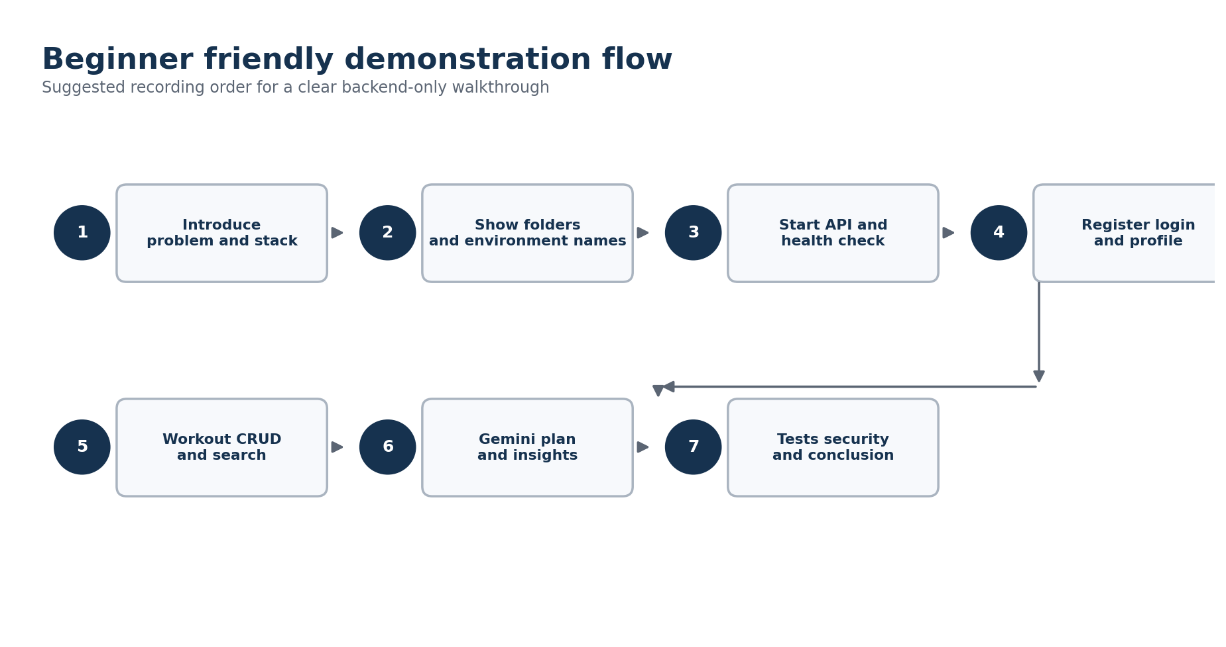
Figure 1 Recommended recording sequence

Suggested recording structure
Segment | Approximate time | What to show
Introduction | 30-45 seconds | Problem, backend-only scope and technology stack.
Project structure | 45-60 seconds | Routes, controllers, models, middleware, services, tests and Postman.
Startup and health | 30-45 seconds | Start server and call GET /api/health.
Authentication | 60-90 seconds | Register, login, save token and retrieve profile; optionally show 401 without token.
Workout management | 2-3 minutes | Create, list, get, update, three searches, delete and follow-up 404.
Gemini AI | 1.5-2 minutes | Recommendation, submitted insights and database insights.
Testing and conclusion | 60-90 seconds | Test summary, security points, repository and final outcome.

Step-by-step demonstration actions

Step 1 Introduce the project
- Show the repository title and README without scrolling through any sensitive values.
- State that AI FitTrack is a backend-only REST API for secure workout tracking and AI guidance.
- Name Node.js, Express.js, MongoDB, Mongoose, JWT and Google Gemini AI.

Step 2 Show the code structure
- Expand server/routes, controllers, models, middleware, services, utils, tests and postman.
- Briefly open User.js, Workout.js, authMiddleware.js and geminiService.js.
- Do not open server/.env. Show .env.example only if configuration names are needed.

Step 3 Start the backend and check health
cd server
npm start
GET http://localhost:5000/api/health
Expected: HTTP 200, success true, status ok

Step 4 Demonstrate authentication
- POST /api/auth/register with a temporary name, email and private password. Point out HTTP 201, the JWT and the absence of the password.
- POST /api/auth/login with the same account. Save the returned token to the Postman collection variable without exposing it.
- GET /api/auth/profile with the token and show HTTP 200.
- Optionally disable the Authorization header and show HTTP 401, then restore the token.

Step 5 Demonstrate workout CRUD and search
- Create a workout and point out that the owner comes from the JWT.
- List workouts and retrieve the created record by its identifier.
- Update duration or calories and show the changed response.
- Run name, category and date searches and show count and filters.
- Delete the workout and retrieve it again to show 404.

Step 6 Demonstrate Gemini AI
- Create two or three demo workouts if database-derived insights need meaningful statistics.
- Call workout-recommendation with a safe profile and show the structured weekly schedule, tips, recovery and safety sections.
- Call fitness-insights with submitted statistics and show the structured analysis.
- Call fitness-insights with useDatabaseStats true and compare returned totals with the demo workout records.

Step 7 Close with verification and security
- Show the final automated test command and summary from the frozen commit.
- Mention bcrypt password hashing, JWT route protection, owner isolation, validation, centralized errors and bounded Gemini retries.
- Show the public repository URL and explain that private secrets are excluded.
- Delete the temporary demo records after the recording.

Voice-over script
Opening: Hello, we are Team SWTID-2026-8100. Our team leader is Parthiban M, and the team members are Naveen J, Nidesh N S and Nithish Kumar P. We are presenting AI FitTrack, a backend-only fitness tracking project developed for SmartBridge Naan Mudhalvan. The backend helps users securely manage workout records and receive AI-based workout recommendations and fitness insights.
Stack: The project uses Node.js and Express.js for the REST API, MongoDB and Mongoose for data storage, JWT for authentication, bcrypt for password protection and Google Gemini AI for structured fitness guidance.
Structure: The source is divided into routes, controllers, models, middleware, services and validation utilities. This separation keeps authentication, workout logic, database access and AI integration easy to maintain and test.
Authentication: First, I register a temporary user. The API returns HTTP 201, a Bearer token and safe user information. The password is never returned. I then log in and use the token to access the protected profile route. Without the token, the same route returns HTTP 401.
Workouts: Next, I create a workout. The backend takes the owner from the verified JWT, so a client cannot assign the workout to another user. I can list the history, retrieve one workout, update it, search by name, category or date and finally delete it.
Gemini: The AI recommendation endpoint accepts age, fitness goal and experience level and returns a structured weekly plan with exercises, recovery, safety and motivation. The insight endpoint can use submitted totals or calculate statistics from the authenticated user's own MongoDB workouts.
Quality: The project includes validation, standardized JSON responses, centralized errors, rate limiting and bounded Gemini retries. The supplied verification records report 95 automated test passes, 17 smoke checks, 19 Atlas checks and successful live authentication, workout and Gemini flows.
Closing: AI FitTrack meets the backend requirements and is ready for integration with a future web or mobile interface. The source and documentation are available in the public repository shown on screen. Thank you.

Video checklist
Check | Before recording | After recording
Secrets | Hide .env, tokens, keys, passwords and MongoDB URI. | Review the full video frame by frame for accidental exposure.
Source | Use the frozen final commit. | Confirm the shown commit is the submitted repository version.
API | Prepare collection variables and temp data. | Confirm all shown statuses and payloads are readable.
Tests | Run once privately to confirm readiness. | Include the final summary from the same commit.
Audio | Use a quiet room and test microphone level. | Check that narration is clear and synchronized.
Privacy | Use a temporary email and neutral sample values. | Delete temporary Atlas records and local captures containing secrets.
Submission | Prepare repository and document links. | Set video access to evaluator-viewable and test the link.

Common troubleshooting
Problem | Check
Server exits before listening | Confirm JWT_SECRET and MONGO_URI exist locally and Atlas permits the current network.
401 on protected route | Use Authorization: Bearer <token>; re-login if the token expired.
CORS error | Add the frontend origin to CLIENT_URL or use Postman for the backend demo.
Gemini 503 | Confirm GEMINI_API_KEY is configured locally and valid.
Gemini 429 | Wait for Retry-After and avoid repeated clicks.
Search date returns no record | Use the stored UTC calendar date and a valid YYYY-MM-DD input.

Items requiring student confirmation
Pending item | What to provide
Individual identifiers | The four names and team designations are included. NM IDs and register or roll numbers were not supplied.
Institution details | College name, academic year, guide or mentor name and official submission date need confirmation.
Responsibility allocation | Team Leader and Team Member designations are recorded, but module ownership and task responsibilities were not supplied.
Repository | Insert the final public GitHub repository URL after upload.
Deployment | Insert the deployed API base URL if the evaluator requires a hosted demonstration.
Demonstration video | Record the video using Phase 8 and insert the final shareable video URL.

